* Download Mamp, xampp or any other software that can run php and mysql servers using PhpMyAdmin. Prefer mamp over others. MAMP stands for Macintosh, Apache, MySQL, and PHP. It is an easy to use application. You can install on your MacOS and Windows.
* Go to MAMP official Website [**https://www.mamp.info/en/**](https://www.mamp.info/en/).
* Click Free Download.

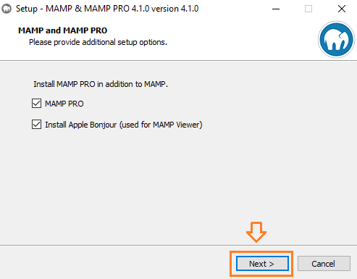

* Select the path.
* By default, it chooses the C:/ drive, but it is not a good practice to install on C:/ drive because if Windows gets corrupt or stops work, you will lose yourdata as well.

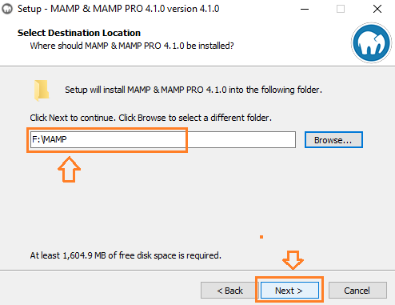

After it is installed open Mamp.

* It may show you an error, "APACHE needs open port 80 which is already used by System".
* It means that port 80 is being used by some other application like Skype or IIS or WAMP etc.
* Click Setup new port.

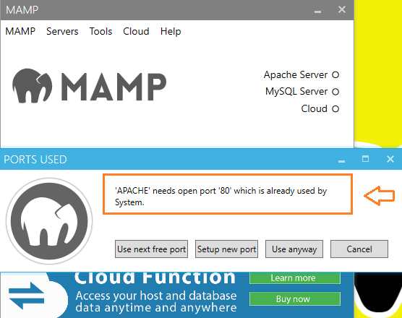

* Click MAMP.
* Click Preferences.
* Click Ports.
* Click Set MAMP ports to default.
* Click OK.
* 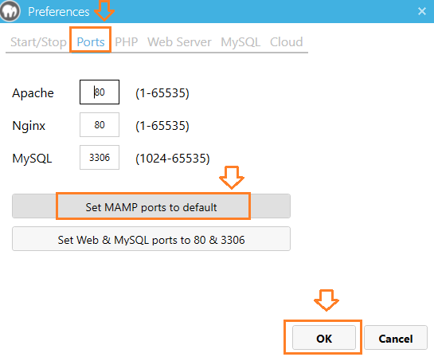
* You can see the ports have been changed.
* Click OK.
* 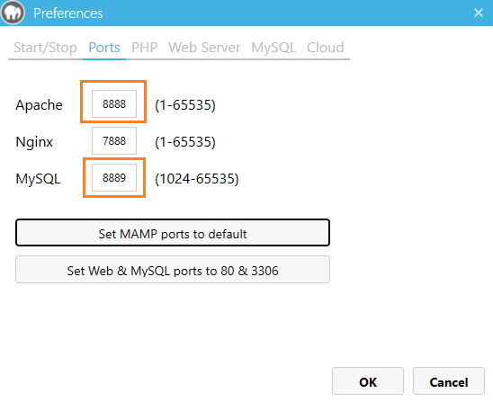
* Since the ports have been changed, we need to run the MAMP Server again.
* So now your ports for apache is 8888 and 8889 for mysql.
* If you can’t have access to these ports then you can choose any other number but you will have to change it in the code.In such case check readmefirst.
* Now your Mamp is all set
* Open the folder where your mamp is installed and then you will find htdocs folder , now paste the project folder in it.
* My path looks like **F:\MAMP\htdocs\Webdevpro-master**
* Now run this on localhost.
* The URL would be: **http://localhost:8888/Webdevpro-master/load.php**
* Remember it will only work if 8888 is your apache port.
* Now you are all set!!
* click the Open WebStart page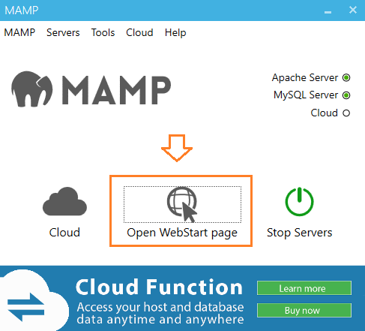
* Now click on phpMyAdmin as shown. 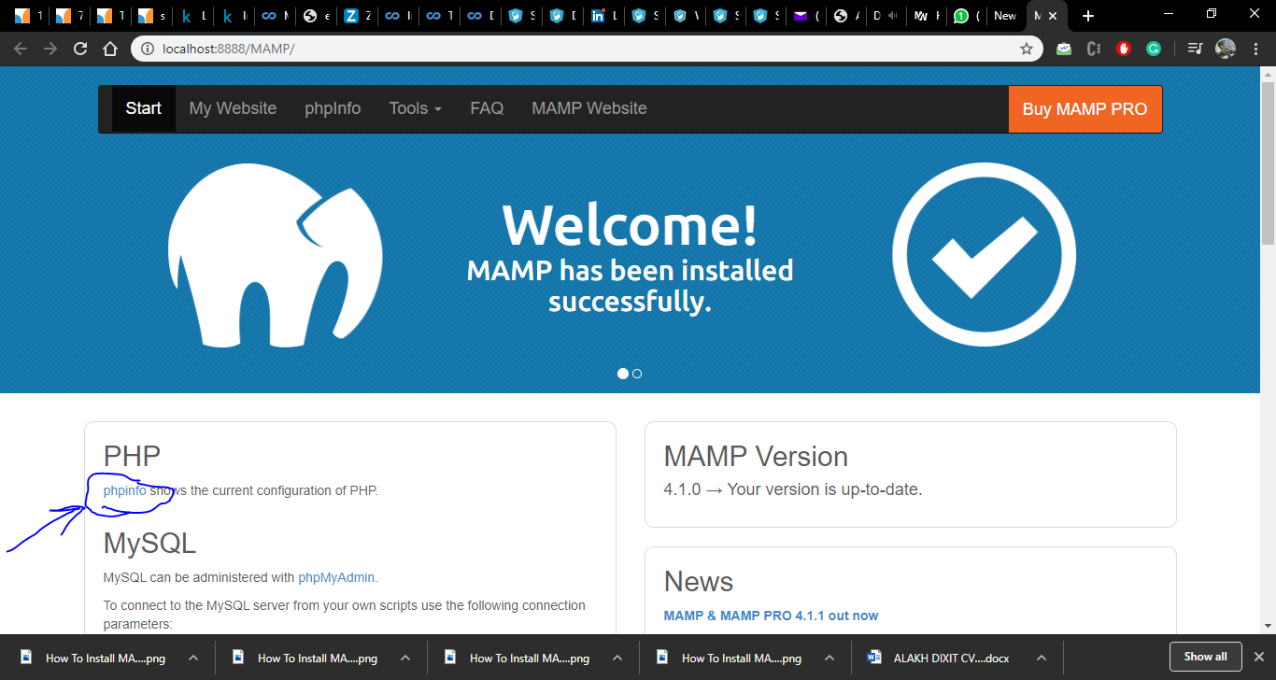

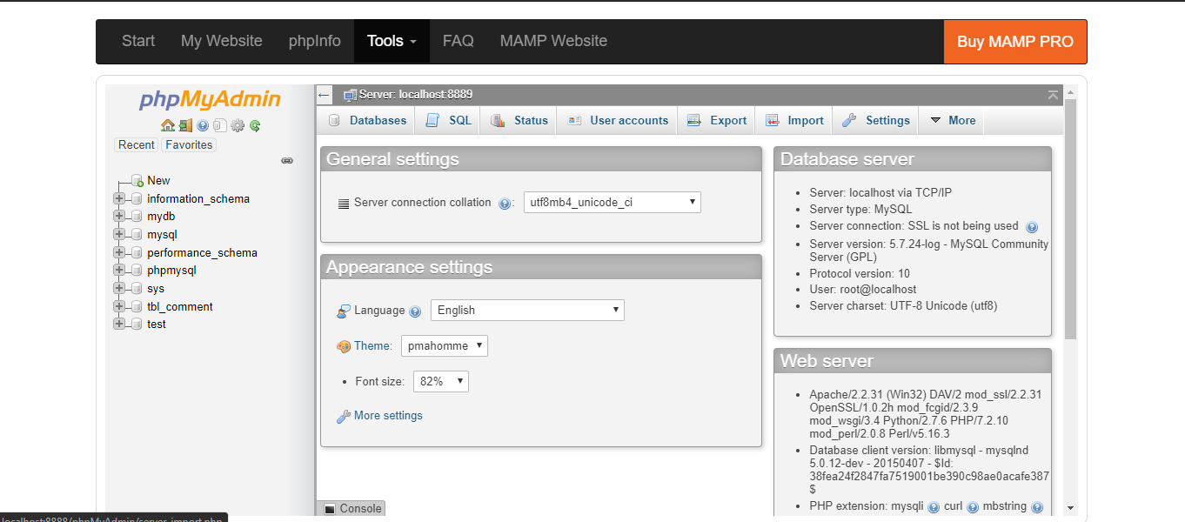

Click On Import option and then drag the mydb.sql file from project folder to it this will load the database in your local PC.